[jupyter notebook - How to use R with Google Colaboratory? - Stack Overflow](https://stackoverflow.com/questions/54595285/how-to-use-r-with-google-colaboratory)

Go this URL <https://colab.to/r> whilst signed into colab and that should do it.

You can check if R in Runtime -> Change runtime type, but it should already be setup.

Go this URL <https://colab.to/r> whilst signed into colab and that should do it.

You can check if R in Runtime -> Change runtime type, but it should already be setup.

[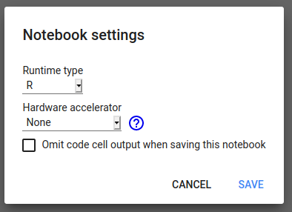](https://i.stack.imgur.com/I01TH.png)

**To mount google drive:**

install.packages("googledrive")

library("googledrive")

if (file.exists("/usr/local/lib/python3.6/dist-packages/google/colab/_ipython.py")){

install.packages("R.utils")

library("R.utils")

library("httr")

my_check <- function() {return(TRUE)}

reassignInPackage("is_interactive", pkgName = "httr", my_check)

options(rlang_interactive=TRUE)

}

**And authenticate google drive**

drive_auth(use_oob = TRUE, cache = TRUE)

[Share](https://stackoverflow.com/a/64827704)